**RELATIONAL SCHEMA:**

* + 1. **Admin**

• **Primary Key**: adminID

• **Attributes**: name, username, password, role, permissions

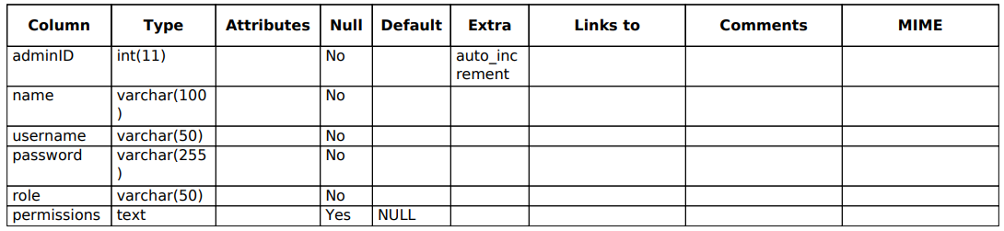

* + 1. **Campaign**

• PrimaryKey: CampaignID

• Attributes: Goal, FundsRaised, StartDate, EndDate

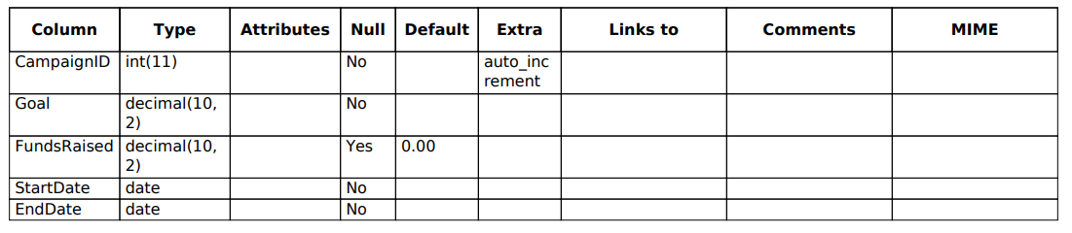

* + 1. **Donation**

• **Primary Key**: DonationID

• **Attributes**: Amount, Date, PaymentMethod, DonorID (FK), CampaignID (FK)

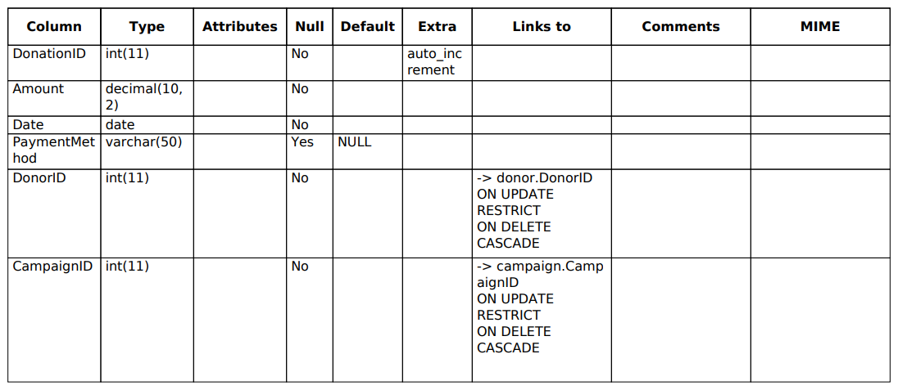

* + 1. **Donor**

• **Primary Key**: DonorID

• **Attributes**: Name, ContactInfo, DonationHistory, Preferences

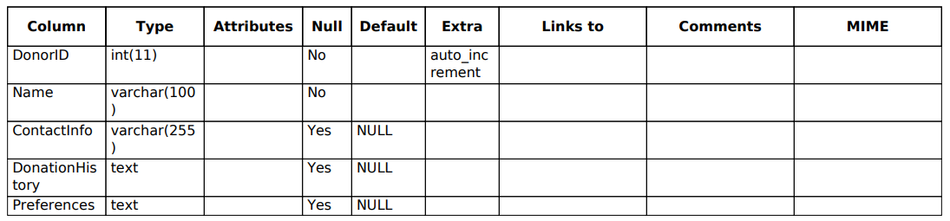

* + 1. **Event:**

• **Primary Key**: EventID

• **Attributes**: Name, Date, Location, CampaignID (FK)

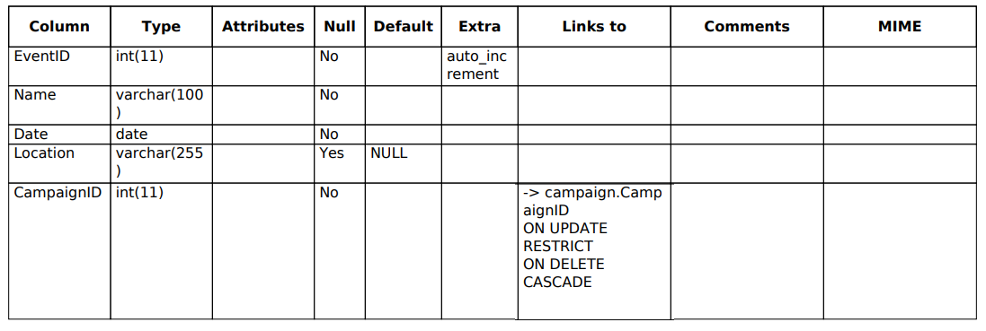

* + 1. **Receipt**

• **Primary Key**: ReceiptID

• **Attributes**: DonationID (FK), Date, Amount

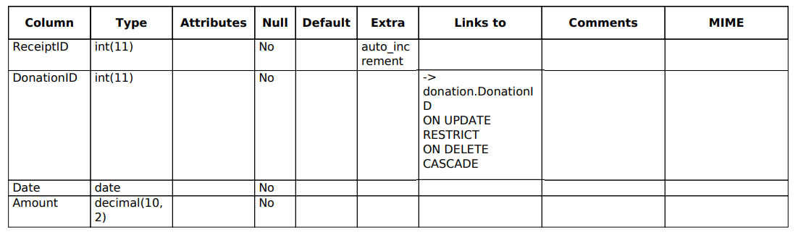

* + 1. **Users**

• **Primary Key**: donorID

• **Attributes**: username, password

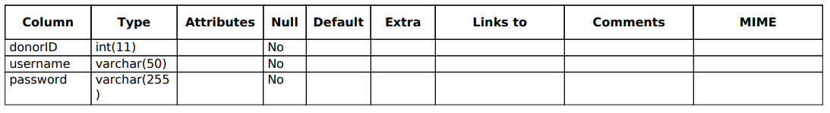

**SCHEMA:**

